**Salesforce NGO Donation & Volunteer Management System  
Daily Development Log**

This document records the day-wise development progress of the Salesforce Capstone Project – NGO Donation & Volunteer Management System. Each day corresponds to a project phase and includes tasks completed, deliverables, and status updates.

# Day 1 – Phase 1: Problem Understanding & Industry Analysis

## Tasks Completed:

• Requirement Gathering: Identified main features – donor registration & donation tracking, volunteer registration & event assignment, event management, automated emails, reporting.

• Stakeholder Analysis: Defined key stakeholders – NGO Admin, Donor Manager, Volunteer Manager, Donors, Volunteers.

• Business Process Mapping: Outlined donor cycle, volunteer cycle, and event cycle; created process flow diagram.

• Industry-specific Use Case Analysis: Researched NGO practices with Salesforce (Nonprofit Success Pack).

• AppExchange Exploration: Reviewed existing solutions like NPSP, Volunteer Management apps.

## Deliverables:

• Requirements_Day1.docx uploaded to GitHub.

• ProcessFlow_Day1.png (business process diagram) uploaded to GitHub.

## Status

• Completed requirement gathering, stakeholder analysis, business process mapping, industry-specific use case analysis, and AppExchange exploration for the NGO Donation & Volunteer Management System. Uploaded requirements document and process flow diagram to GitHub.  
  
  
  
  
  
**Day 2 – Daily Progress Report**

### What I worked on today

Today, I focused on building the **core data model** for our Salesforce NGO Donation & Volunteer Management System.

* I created **four main custom objects**: Donor, Donation, Volunteer, and Event.
* I added the important fields for each object, such as email, phone, donation amount, date, event capacity, skills, etc.
* To connect donations with donors, I set up a **lookup relationship** so that every donation record is linked to the correct donor.
* For volunteers and events, I designed a **many-to-many relationship** using a junction object called **Volunteer Event Assignment**. This allows multiple volunteers to join the same event and the same volunteer to participate in many events.
* I also set up **tabs** for all custom objects and added them to our **NGO Manager app**, so now they are easily accessible from the App Launcher.
* Finally, I tested the junction object by assigning volunteers to events — it worked as expected, confirming the model is functional.

### What I achieved today

* A **complete data model** with all objects, fields, and relationships.
* A **junction object** that enables flexible volunteer-event assignments.
* A **custom app (NGO Manager)** where all objects are visible and easy to use.

### Screenshots:

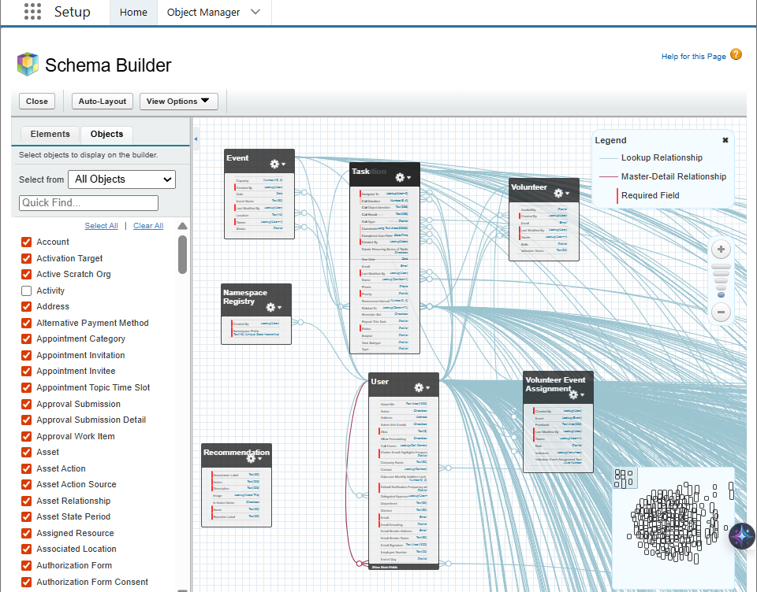

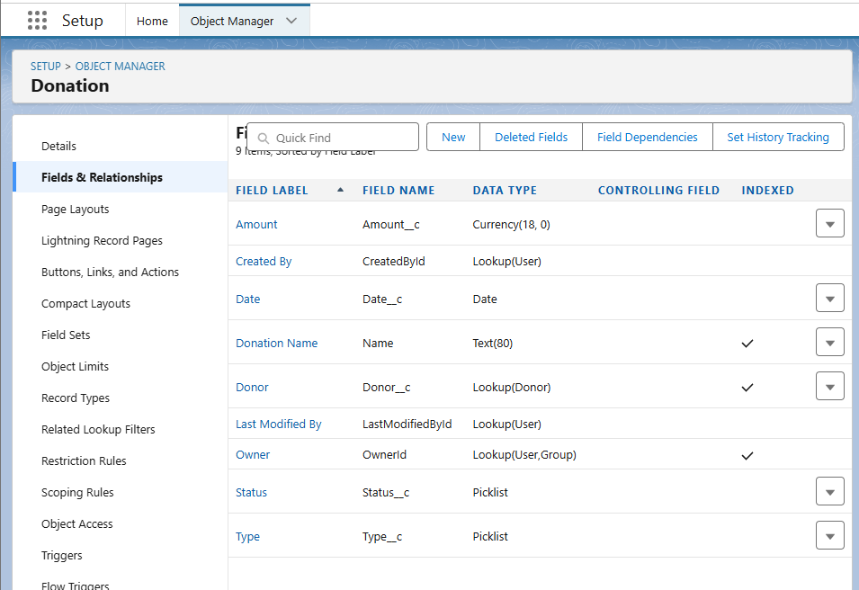

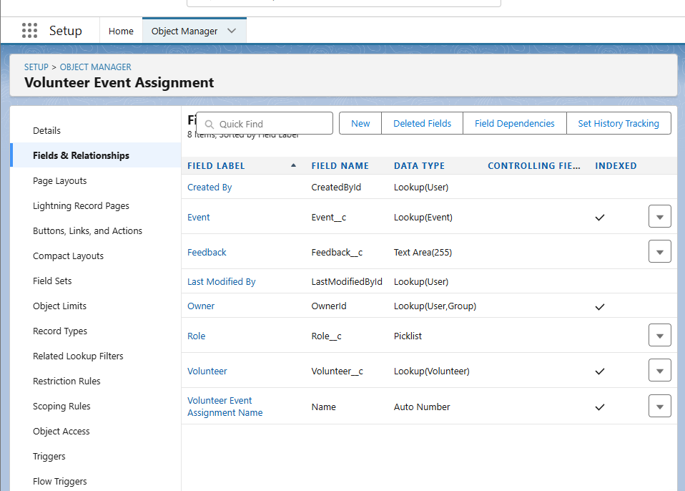

### Day 3 – Daily Progress Report

### What I worked on today

Today, I focused on building **automation and workflows** for our Salesforce NGO Donation & Volunteer Management System.

* I created **validation rules** to improve data quality: one to ensure donation amounts are always greater than zero, and another to stop volunteers from being assigned to events that have no available slots.
* I built two **record-triggered flows**:  
  + The first flow sends a **thank-you email** automatically whenever a new donation is created.
  + The second flow updates the **available slots on an event** whenever a volunteer assignment is made, ensuring event capacity stays accurate.
* I set up an **approval process** for high-value donations (above 50,000). When such donations are entered, they are marked as pending and an email notification is sent to the approver for review.
* Finally, I created two **email templates**: one for thanking donors and another for notifying managers about high-value donations. These templates ensure consistent communication.

What I achieved today

* Data validation to prevent wrong entries.
* Smart automation with flows to reduce manual work.
* Approval process for handling big donations in a professional way.
* Reusable email templates for donor and manager communication.

